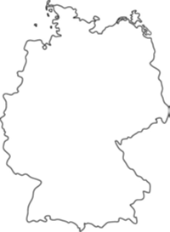ooxWord://word/media/image2.pngooxWord://word/media/image3.pngooxWord://word/media/image4.pngooxWord://word/media/image5.png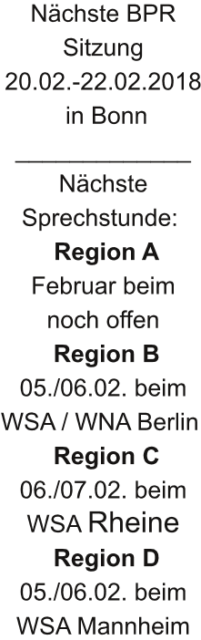ooxWord://word/media/image7.pngooxWord://word/media/image9.png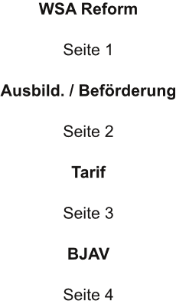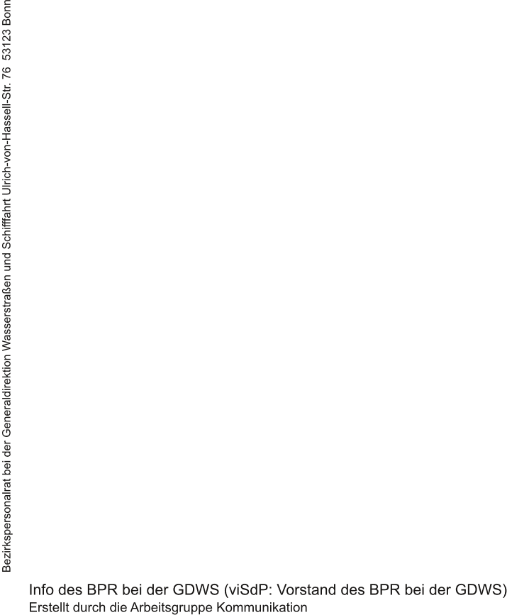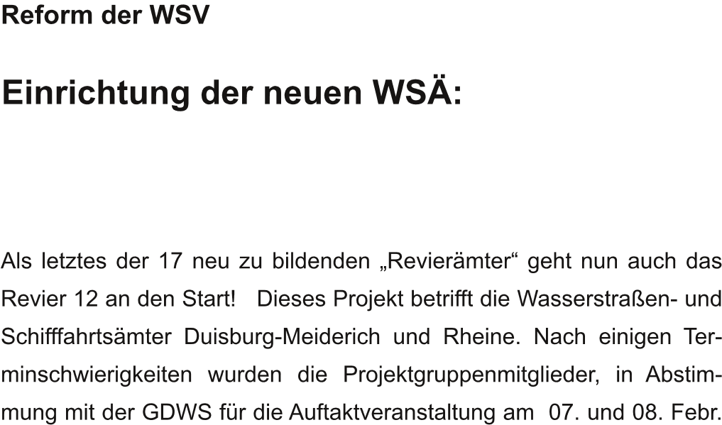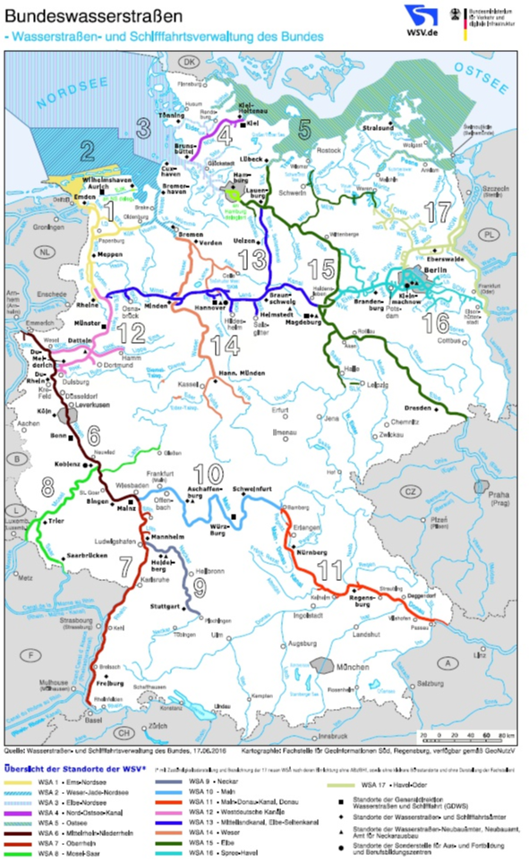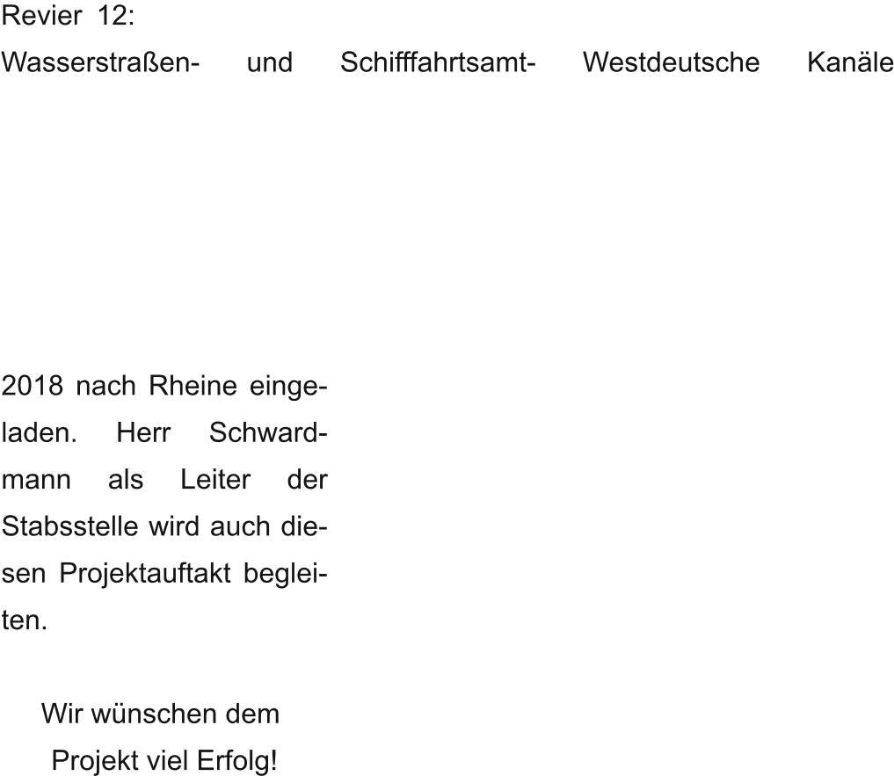Bez

Be

zi

ir

rk

ks

sp

pe

er

rs

so

on

na

al

lr

ra

at

t b

be

ei

i d

de

er

r G

-  I

GD

01

n f

DW

/ 1

f o

WS

18

o  -

S

8

-

- I n

01 /

ooxWord://word/media/image16.png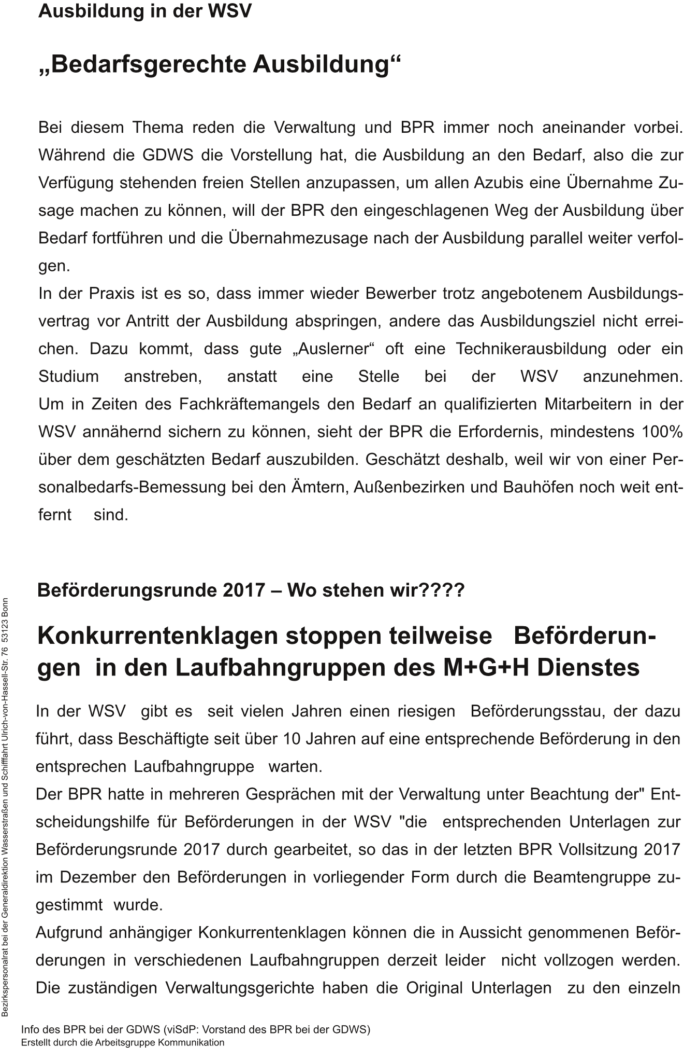ooxWord://word/media/image18.png

ooxWord://word/media/image19.png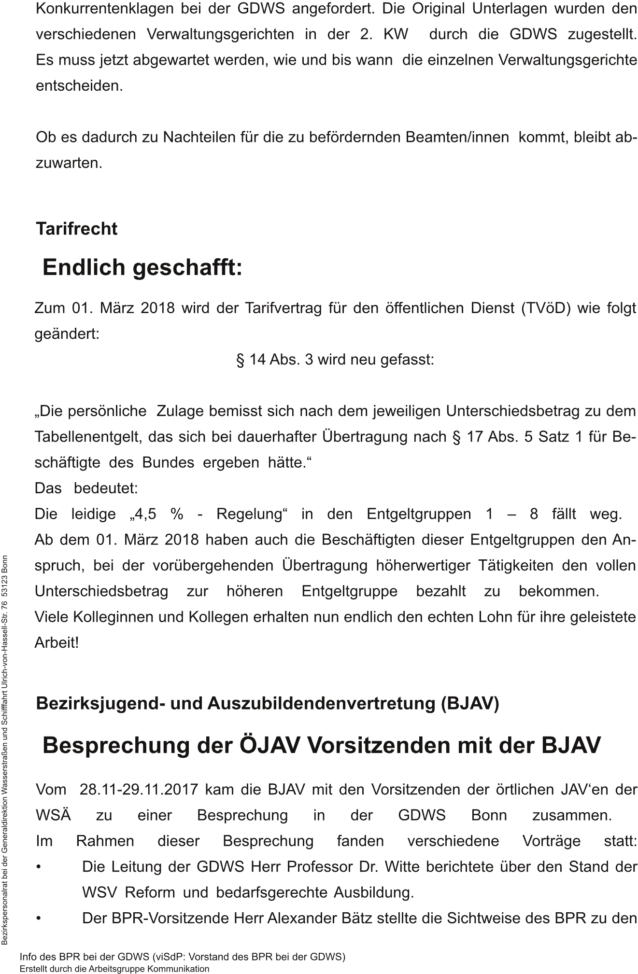

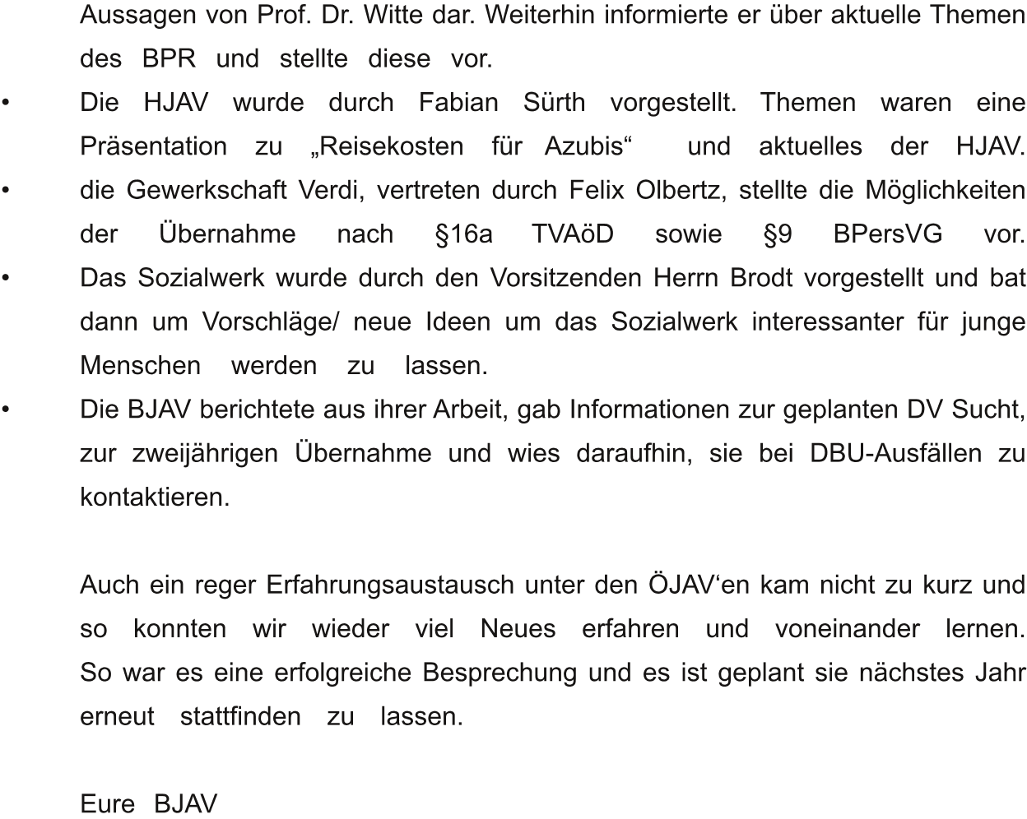ooxWord://word/media/image22.png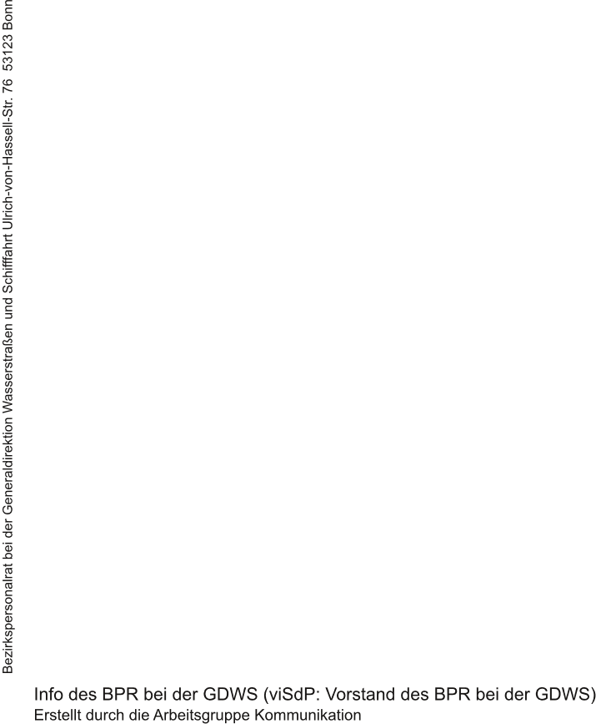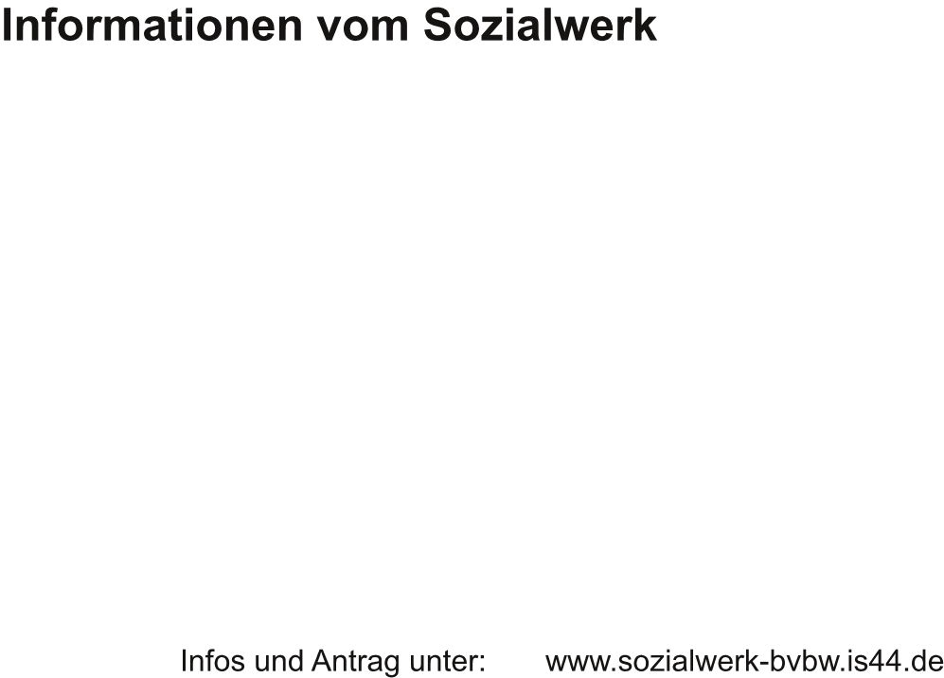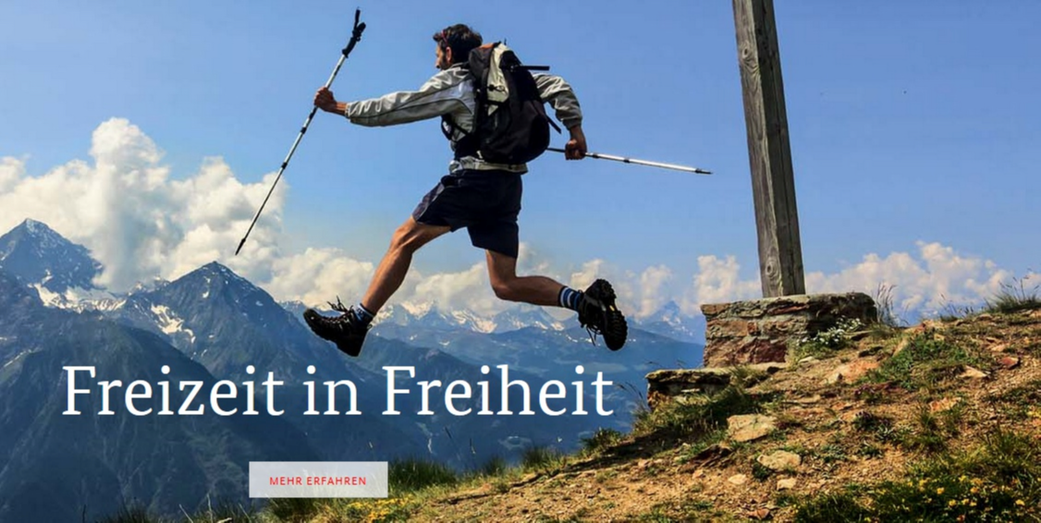

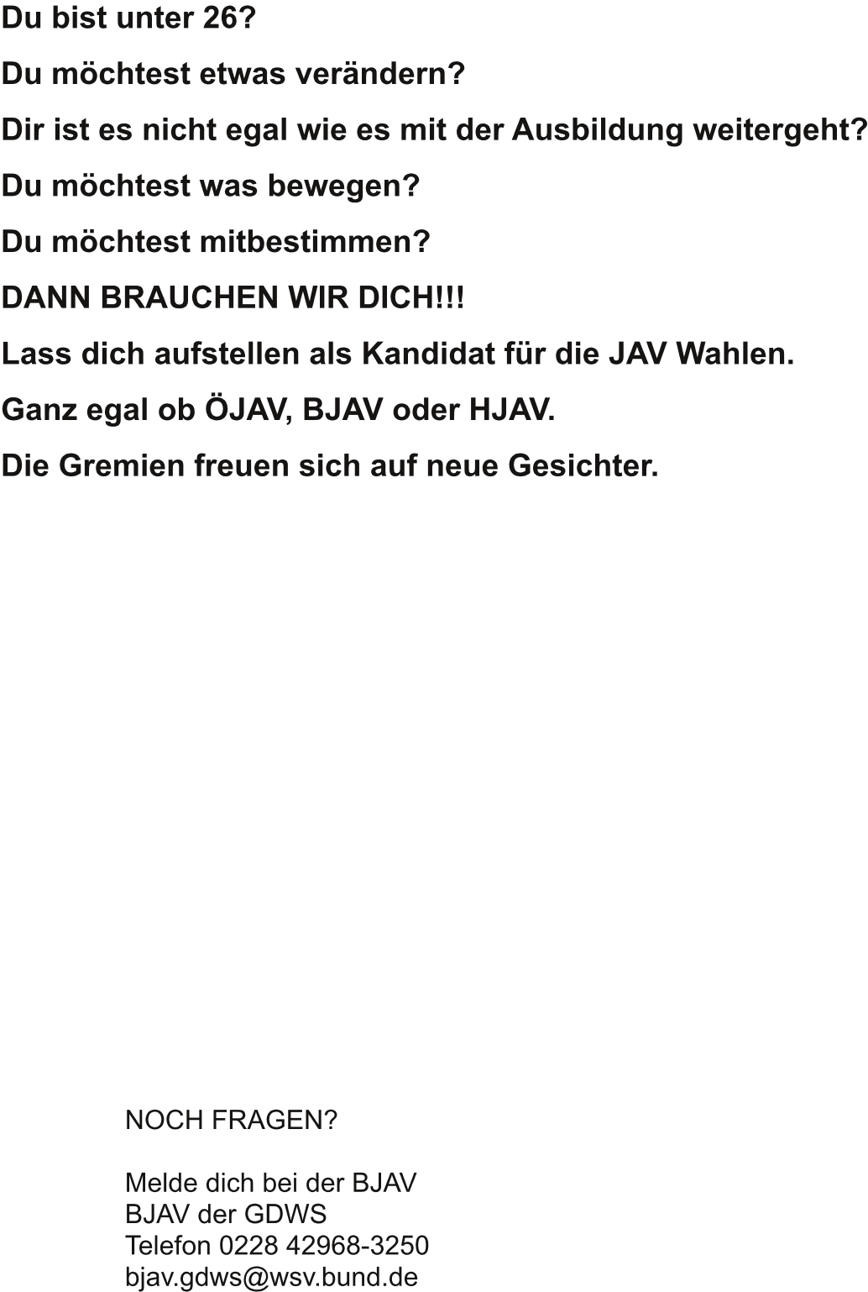ooxWord://word/media/image31.png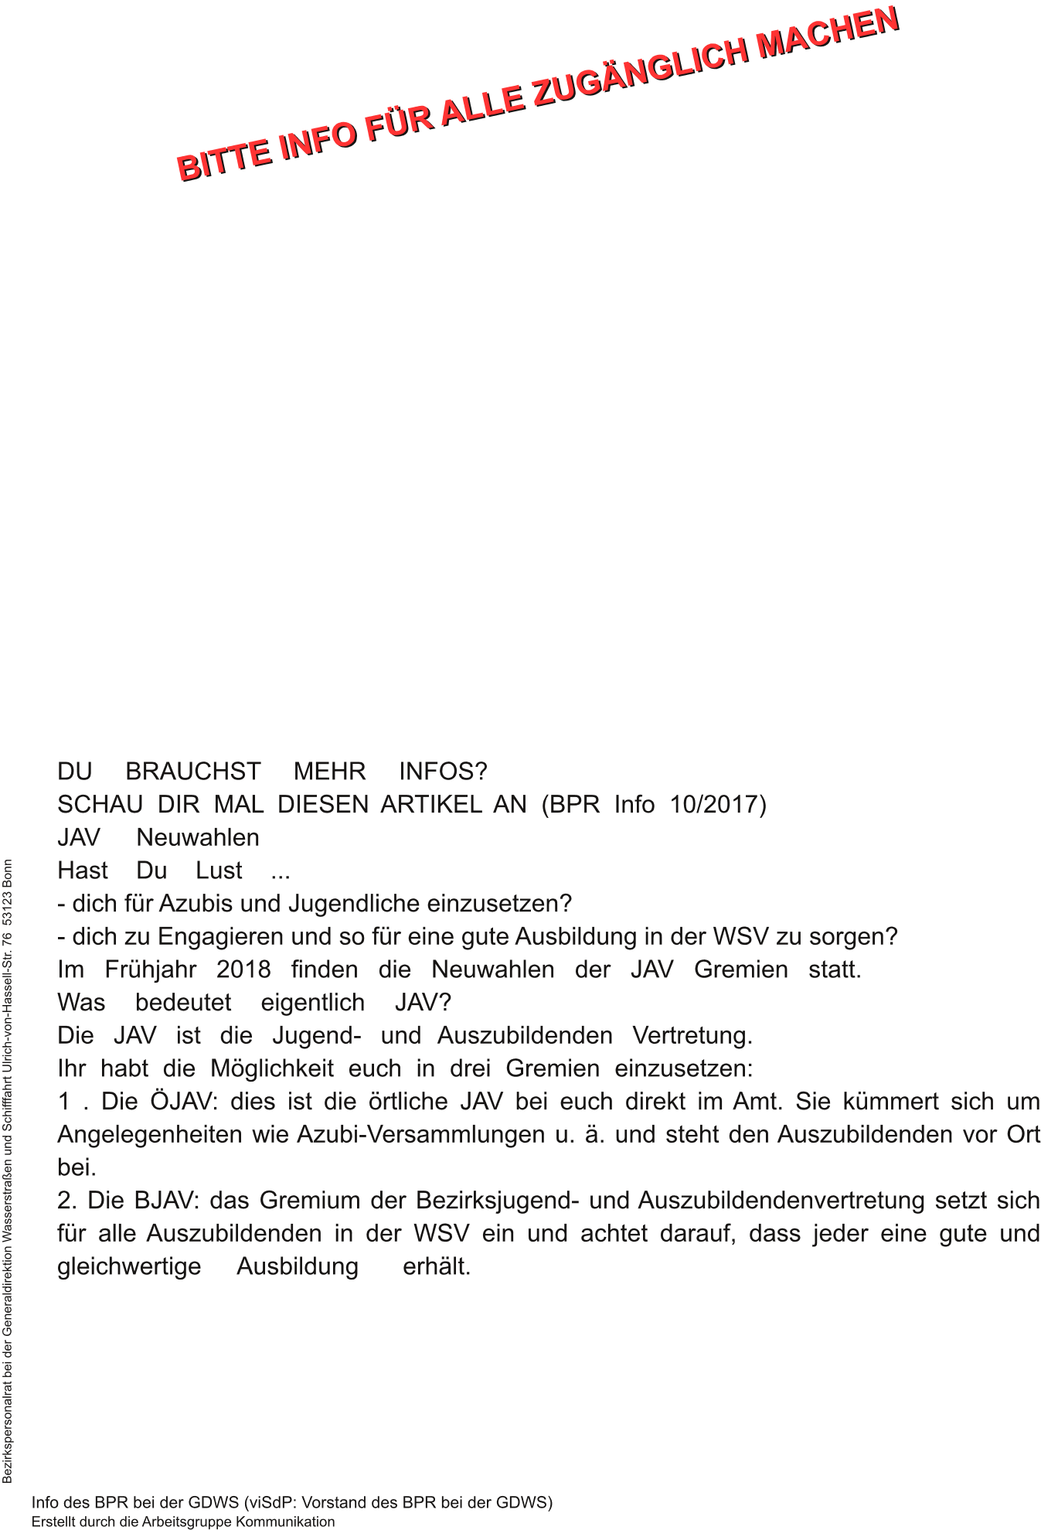ooxWord://word/media/image34.pngooxWord://word/media/image35.png